Chapters 1-2

Empiricism 经验主义
The idea that knowledge comes from *observation and experience*; in psychology, science is *empirical*, meaning it relies on measurable data rather than authority or logic alone (§1.1).看数据不看权威理论

> “Psychological science is empirical, based on measurable data.”

Structuralism 建构主义
(Wundt, Titchener)
Focused on identifying *the components of consciousness* using *introspection*.

> “Structuralism’s focus was on the contents of mental processes rather than their function.” (§1.2)

Functionalism
(James, Dewey, Peirce)
Studied *how mental activities help an organism fit into its environment*.

> “Functionalism focused on how mental activities helped an organism fit into its environment.” (§1.2)

Behaviorism
(Watson, Skinner, Pavlov)
Emphasized *observable behavior* over internal mental states.

> “Watson preferred to focus directly on observable behavior… this approach came to be known as behaviorism.” (§1.2)

Gestalt Psychology
(Wertheimer, Koffka, Köhler)
The *whole* is different from the sum of its parts.

> “Although a sensory experience can be broken down into individual parts, how those parts relate as a whole is what the individual responds to in perception.” (§1.2)

Cognitive Revolution
Mid-20th-century shift back to studying *mental processes* (memory, language, reasoning).

> “By the 1950s new perspectives in linguistics, neuroscience, and computer science revived interest in the mind… this has come to be known as the cognitive revolution.” (§1.2)

Theories and Hypotheses

> “A hypothesis is a tentative explanation… fitting into the context of a scientific theory, a broad explanation supported by evidence over time.”
（hypothesis is used for explaining theories

Descartes & Locke - empiricism and dualism (mind–body problem).
Freud - psychoanalytic theory: behavior and personality shaped by *unconscious drives* and *early childhood*. (§1.2)
Watson – behaviorism; studied learned behavior using objective methods. (§1.2)
Skinner – Studied how *reinforcement and punishment* shape behavior via operant conditioning. (§1.2)

---

Introspection

“A process by which someone examines their own conscious experience as objectively as possible.”

Used by Wundt in early experimental psychology.

---
Case Study – In-depth investigation of one person or few individuals.
Naturalistic Observation – Observing behavior in its natural setting without manipulation.
Survey – Collects self-reported data from many people.
Correlational Study – Measures relationship between two variables; no causal inference.
Experiment – Manipulates independent variable and measures dependent variable under controlled conditions.

Experimental Terms

Random Assignment – Each participant has equal chance of being in any group; ensures group equivalence.
Independent Variable – The manipulated factor.
Dependent Variable – The measured outcome.
Confounding Variable – A factor that could interfere with or explain the results besides the IV.
Experimental Group – Receives the treatment/manipulation.
Control Group – Serves as comparison; no treatment.
Attrition 损耗– Participants dropping out of a study; threatens validity.
Empirical – Based on observation or experiment rather than theory.

Correlation Coefficient

> “A number from −1 to +1 that describes the strength and direction of a relationship between two variables.”
> Closer to ±1 = strong relationship; 0 = none.
> Positive → both increase; Negative → one increases as the other decreases.

---

Research Designs

Between-Subjects – Different groups experience different conditions.
Within-Subjects – Same participants experience all conditions; controls for individual differences.
Cross-sectional
Longitudinal

---

Research Ethics

IRB (Institutional Review Board)– Approves research with human participants.
IACUC (Institutional Animal Care and Use Committee)– Approves animal research.

> “Both IRB and IACUC review proposals to ensure humane, ethical treatment and minimize harm.”

---

Validity vs Reliability

> “Reliability refers to the ability to consistently produce a given result; validity refers to the extent to which an instrument measures what it’s intended to measure.”
“How Valid Are the SAT and ACT?”
> 🔹 Reliable = consistent results; Valid = accurate measure.

Chapter 3:Biopsychology
Neuron – The basic unit of the nervous system that processes and transmits information through electrical and chemical signals.

“Neurons are cells in the nervous system that act as interconnected information processors.”

Dendrites 树突– Branch-like extensions that receive incoming signals.

Soma (Cell Body) – Contains the nucleus; integrates incoming information.

Axon 轴突– Long fiber that transmits signals to other neurons.

Myelin Sheath 髓鞘– Fatty covering on the axon that increases the speed of signal transmission.

Axon Terminals – Contain neurotransmitters released into the synapse.

🧠Study tip: Think of the neuron as a communication cable — dendrites = input, axon = output.
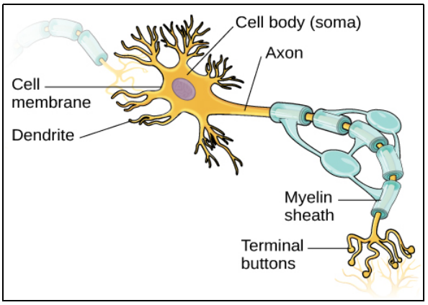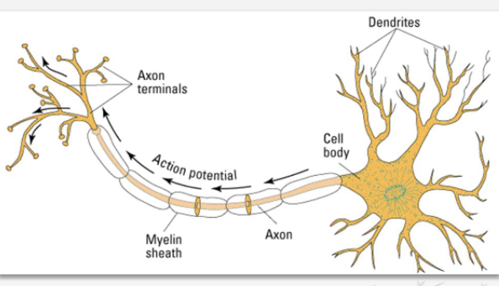

Action Potential 动作电位 （动词）(§3.2)

“The electrical signal that typically moves from the cell body down the axon to the axon terminals.”

Depolarization：Occurs when the neuron’s charge briefly becomes positive .

Followed by repolarization and a refractory period before firing again.

🧠 Remember: “All-or-none”
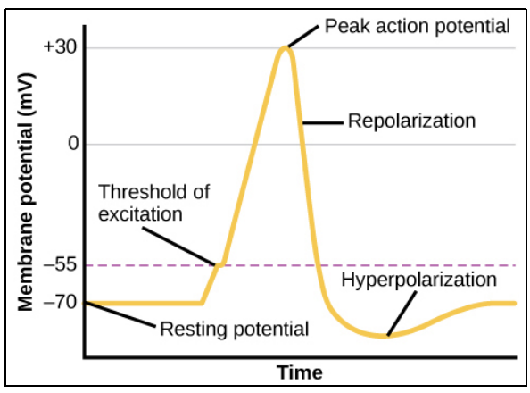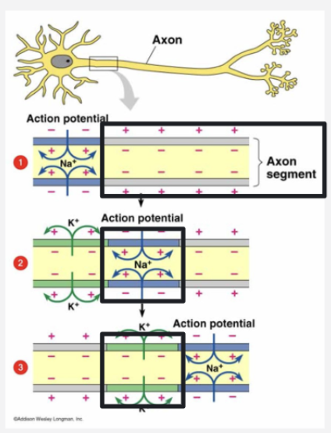

Resting potential: negatively charged potassium ions inside,positively charged sodium ions outside. Axon is polarized.

Action potential: a neural impulse; a brief electrical charge thattravels down an axon. Positively charged ions flood in through the cell membrane. Axon depolarizes, propagates down axon.

Refractory period: the axon pumps the positively charged sodium ions back outside (repolarizes itself). Then it can fire again (is back in resting state Resting Potential）

“When a neuron is not actively sending a signal, it has a resting potential of about –70 mV.”
Synapse 突触

“The synapse is a very small space between neurons and is the site where communication occurs.”
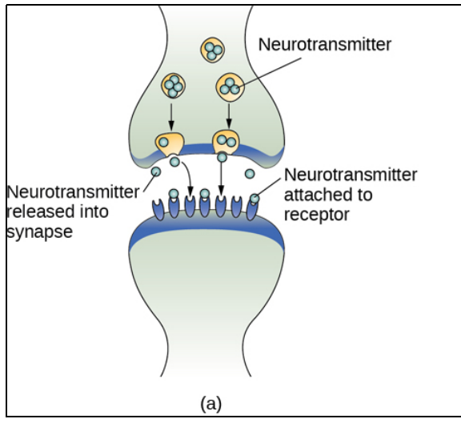
The synaptic cleft is the space between the terminal button of one neuron and the dendrite of another neuron.

Neurotransmitters 神经递质– Chemical messengers released by neurons.
Examples:

Acetylcholine (ACh): muscle movement, memory

Dopamine: mood, reward, movement

Serotonin: mood, sleep

Norepinephrine去甲肾上腺素: alertness

GABA: inhibition (reduces neural activity)

Glutamate: main excitatory neurotransmitter
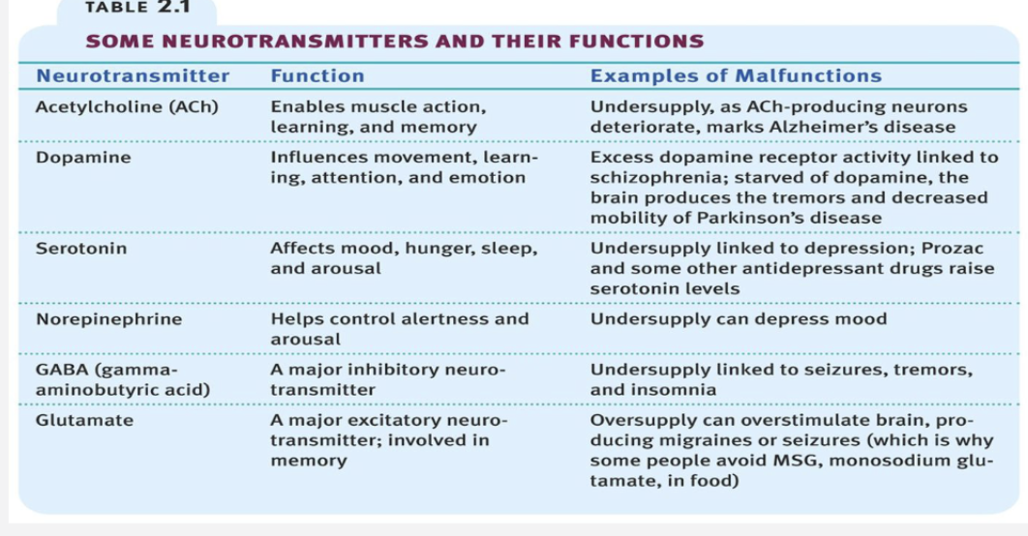

🧠 Tip: Neurotransmitters can be excitatory (increase activity) or inhibitory (decrease activity).

Reuptake：Mechanism for recycling neurotransmitters.

“After neurotransmitters are released into the synaptic cleft, they are often reabsorbed by the neuron that released them.”

Drugs like SSRIs (antidepressants) block reuptake to increase serotonin levels.

The Nervous System (§3.3)

Central Nervous System (CNS) – Brain and spinal cord: connects the brain to the outside world.
Peripheral Nervous System周围神经系统 (PNS) – Connects CNS to rest of body.
--Somatic Nervous System躯体神经系统: voluntary control of muscles, sensory info.
--Autonomic Nervous Syste自主神经系统: involuntary functions (heart rate, digestion).
----Sympathetic nervous system交感神经系统: fight-or-flight response.
“it might fight off a threat or run away to safety”
----Parasympathetic nervous syste副交感神经系统: rest-and-digest recovery system.
“Our hunter’s heart rate and blood pressure return to normal, the pupils constrict,
bladder control is restored”

🧠 Tip: “Sympathetic = stress; Parasympathetic = peace.”

Endocrine System内分泌系统 (§3.4)
“The endocrine system consists of glands腺 that produce chemical messengers called hormones.”
Hormones – Chemical substances that travel through the bloodstream.
Pituitary gland脑下垂体: “master gland,” controls others，regulates hormone release
Thyroid gland甲状腺: metabolism and appetite新陈代谢
Adrenal glands（epinephrine）肾上腺: stress response
Tip: Endocrine = slow, bloodstream signals; Nervous = fast, electrical signals.
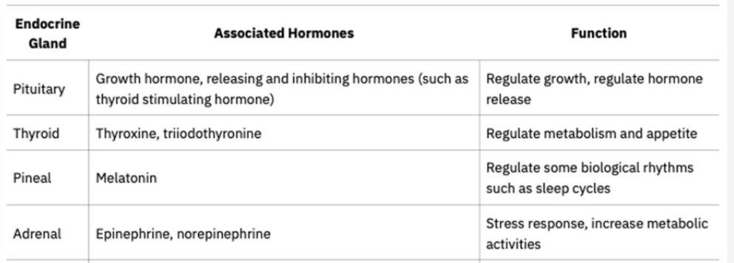

Brain Structures (§3.5)

1. Hindbrain后脑 – Basic life functions and posture

Medulla骨髓: breathing, heart rate.

Pons: sleep regulation

Cerebellum小脑: balance, coordination, learning motor skills.
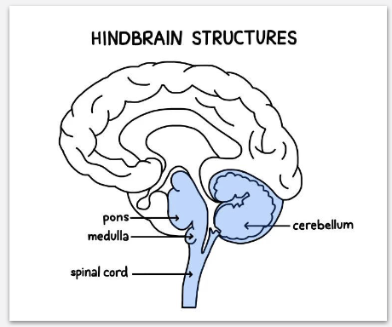
2. Midbrain – visual and auditory reflexes.（视听）

Substantia nigra黑质: dopamine production, movement control.

Tip：Midbrain + Pons + Medulla = Brain Stem

3. Forebrain – higher-order thinking，sensory processing, emotion and memory regulation

Hypothalamus下丘脑: homeostatic自我稳定 progress (hunger, temperature, hormones)

Hippocampus: learning, memory.

Cerebral cortex大脑皮层: outer layer for thought, language, reasoning.

Lobes脑叶 of the Brain (§3.5)
Frontal lobe: thinking, speech, motor control

Parietal lobe: sensory processing, spatial awareness, sensory integration（通感），math

Temporal: hearing, language, memory
Broca’s area: french,producing language
Wernicke’s area: german,speech comprehension

Occipital : vision

🧠 “F-POT ”
Frontal lobe额叶, Parietal lobe顶叶, Occipital lob枕叶, Temporal lobe.
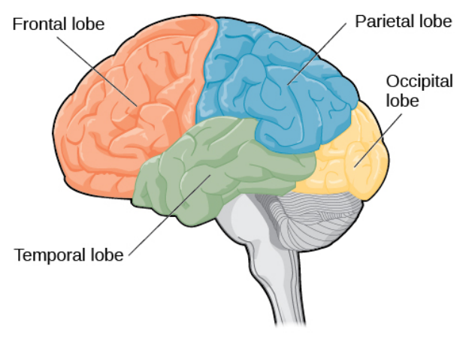

Lateralization : “Each hemisphere of the brain is associated with certain functions.”
Genetics and Behavior (§3.1 & §3.6)

DNA makes up genes.
Genes are found on chromosomes.
Chromosomes are stored inside the cell nucleus细胞核.

Genotype: organism’s genetic makeup.

Phenotype: observable characteristics.

Allele等位基因：a specific version of a gene.

Dominant vs Recessive genes: determine trait expression.

Range of Reaction: genetic limits within which environment influences expression.

Identical&fraternal twins：one or two eggs

Epigenetics实验胚胎学: gene expression can change through experience/environment.

🧠 Tip: Genes set the “range,” environment decides “where you fall” in it.

Chapter 4: States of Consciousness

Consciousness:
The subjective awareness of ourselves and our environment.
Altered State of Consciousness (ASC): Awareness that is distinctly different
from waking consciousnes
Key Features of Attention:
Selective attention: We focus on some stimuli while ignoring others.
Limited capacity: We can only process a small amount of information at a time.

Inattentional blindness – failing to notice something visible when attention is elsewhere (e.g., the “dancing bear” in the basketball video).
Change blindness – failure to detect changes in a visual scene

Circadian Rhythms昼夜节律
A biological rhythm that takes place over a 24-hour period.
Regulated by the suprachiasmatic nucleus (SCN) in the hypothalamus, which responds to light cues.

Controls **sleep–wake cycles**, **body temperature**, **blood pressure**, and **hormone release**.
Disruption (e.g., jet lag, shift work) can affect alertness and mood.
EEG detects patterns of electrical activity in the brain.

Wave:
Beta: Awake, alert
Alpha: Relaxed wakefulness
Delta: Deep sleep

Stages of Sleep
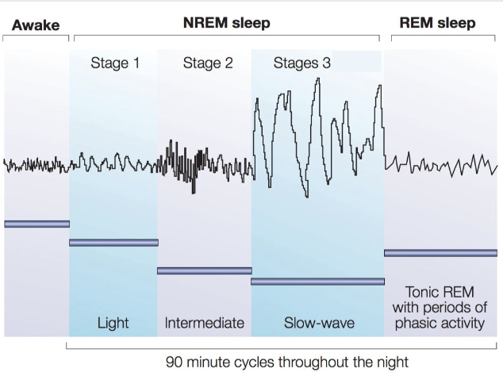

REM plays key roles in learning, memory, and emotional processing.

Theories of Why We Sleep
Restorative Theory: Sleep restores body and brain functions.
Evolutionary Theory: Sleep patterns evolved for survival and energy conservation.
Cognitive Function Theory: Sleep supports memory consolidation巩固 and learning.

Theories of Why We Dream

Freud’s Dream Theory: Dreams represent wish fulfillment of unconscious desires.
Activation-Synthesis合成Theory: Dreams result from random brain activity organized by the brain into a story.
Collective Processing Theory: Dreams help process emotions and memories.

Sleep Disorders
Insomnia
➔ Recurring problems in falling or staying asleep
Narcolepsy嗜睡
➔ Sudden uncontrollable sleep attacks, sometimes lapsing directly into REM sleep
Sleep apnea呼吸暂停
➔ Stopping of breathing while asleep; associated with obesity, especially in men
Night terrors
➔ High arousal and appearance of being terrified
Sleepwalking and sleeptalking
|

---

Hypnosis催眠: Narrow attention and increase openness to suggestion

What hypnosis can do:
Alter sensory experiences (pain perception).
Improve focus or recall under suggestion.

What hypnosis cannot do:
Make someone act against their moral values.
Give “superhuman” powers or perfect memory.

Psychoactive Drugs
Depressant
Alcohol barbiturates opiates鸦片制剂
Slow CNS activity
Stimulant
Caffeine nicotine cocaine amphetamine mdma
Increase alertness, mood, energy; boost dopamine

Psychological Dependence
Drug tolerance & withdrawal symptom

Chapter 5: sensation and perception

Transduction变频: The conversion from sensory stimulus energy to action potential.

Absolute Threshold: The minimum stimulation necessary to detect a particuar stimulus 50% of the time.
Example: The faintest sound you can hear or the dimmest light you can see.

Just Noticeable Difference (Difference Threshold): the minimum difference a person can detect between any two stimuli 50% of the time.
Weber’s law: To be perceived as different, two stimuli must differ by a constant minimum percentage (rather than a constant amount)

---

Types of Receptor Cells (for each sense)
Vision:
-rods: night time,achromatic
-cones: day time,chromatic
In retina视网膜
Hearing: hair cells毛细胞(in cochlea耳蜗)
Tasting: taste receptor cells on the tongue
Smelling: olfactory receptors
Touch: 看不懂的两个

Fovea （视网膜里最厉害的）：for details

Trichromatic Color Vision Theory: color vision is based on three types of cones
红绿蓝，长中短波

Opponent-Process Theory
Suggests color is processed in opposing pairs:
Red–Green
Blue–Yellow
Black–White
Afterimages (seeing green after staring at red) support this theory.

Monocular单眼的 Depth Cues
Cues available to one eye that help perceive depth and distance.
Linear perspective
Interposition (near objects block farther ones)

---

Binocular Depth Cues
Binocular disparity双眼差异 (retinal disparity):
Each eye sees a slightly different image; the brain combines them to judge depth.
Convergence汇聚: Eyes move inward more for closer objects.

Bottom-Up Processing: outer input--environment
Perception that starts with sensory input — the data coming from the environment

Top-Down Processing: inner output--experience
Perception influenced by prior knowledge, experience, and expectations.*

Gestalt Psychology: The brain naturally groups stimuli to make sense of patterns
“The whole is different from the sum of its parts.”

Gestalt Laws of Organization:
Law of proximity邻近, similarity, continuity, closure

Chapter 6: learning

Three Requirements of Learning
1.change in behavior or knowledge
2.relatively permanent
3.due to experience (not reflexes or instincts)

Reflex vs. Instinct
Reflex: simple and immediate response
Instinct: more complex and coordinated by several body functions

Classical Conditioning (Pavlov)
Discovered by Pavlov through dog salivation experiments
-Before conditioning:
Unconditioned stimulus(us):food
Unconditioned response(ur):salivation after food
Neutral stimulus(ns):bell
-after conditioning
Conditioned stimulus(cs):bell as food
Conditioned response(cr):salivation after bell

Extinction
When the conditioned response decreases after repeated presentation of the conditioned stimulus without the unconditioned stimulus.

Timing of Stimuli in Classical Conditioning
Best:forward pairing--CS precedes the US
Simutaneous pairing
backward pairing

Generalization: Responding similarly to stimuli that resemble the CS.
Dog salivates to a tone similar to the original bell.
Discrimination: Learning to respond only to the specific CS.
Dog salivates only to one tone but not others.

Latent Learning (Tolman)

Learning that occurs but is not demonstrated until there is motivation to do so.

Little Albert Experiment (Watson & Rayner, 1920)**
Illustrates: Emotions can be conditioned responses.

Phobias恐惧症

Systematic Desensitization (Wolpe)：
A behavioral therapy that reduces phobic anxiety through gradual exposure paired with relaxation.

Steps:
1. Build anxiety hierarchy.
2. Learn relaxation techniques.
3. Gradually expose the person to fear stimuli while relaxed.

Law of Effect (Thorndike)
Behaviors followed by satisfying outcomes are likely to be repeated; those followed by unpleasant outcomes are less likely to recur.

Operant Conditioning 操作性条件反射(Skinner)
Learning through consequences — behavior is strengthened or weakened depending on its results.

Operant Chamber (Skinner Box)
A controlled environment for studying animal learning, with levers or buttons to deliver food (reinforcement) or shock (punishment).
Used to measure how behavior changes in response to consequences.

Reinforcement Types
Primary reinforcement: food
Secondary reinforcement: money and praise
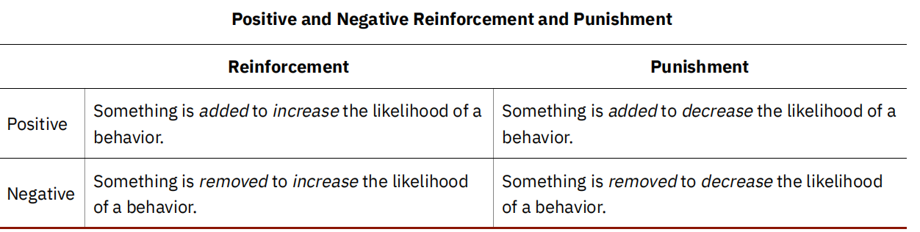

Punishment
A consequence that decreases the frequency of a behavior

Limits of punishment:
doesn’t teach correct behavior
often suppresses behavior temporarily
may cause fear or aggression

Shaping
Reinforcing successive逐步 approximations toward a desired behavior.

Schedules of Reinforcement
Interval: time Ratio: response
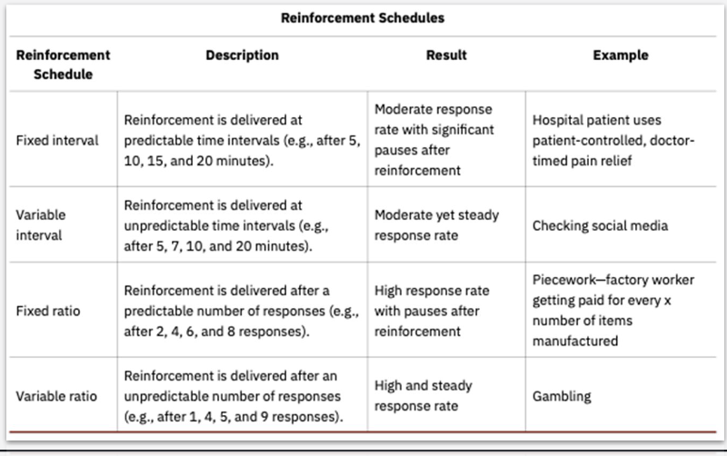

Observational Learning (Bandura)
Learning by watching and imitating others.
Albert Bandura’s Bobo doll study: children imitate aggressive models.

Key processes:
1. Attention – Watch the model.
2. Retention留存 – Remember the behavior.
3. Reproduction – Be able to perform it.
4. Motivation – Want to perform it (based on rewards or consequences).

Chapter 7: Thinking and intelligence

Concept
A category or group of linguistic information, objects, ideas, or life experiences that are similar.
Concepts help us organize information efficiently.

Prototype原型
The best example or representation of a concept.
Acts as a mental “average” of a category.

Schema
A mental framework that organizes information.
Role schema: Assumptions about how people in certain roles behave (e.g., teacher, doctor).
Event schema (cognitive script): Expectations about how events unfold (e.g., ordering at a restaurant).

Phoneme: p,b,m
Morpheme: un,happy
Semantics: book
Orthography: spelling system
Syntax: sentence organization

Lexicon: vocabulary

Measuring Infant Cognitive Ability
HAS Procedure: Infants suck more strongly when interested in a stimulus.
Head-Turning Procedure: Babies turn toward new or familiar sounds; measures recognition and discrimination.

Critical Period
A specific window of time during development when the brain is especially receptive to learning certain skills, like language.*
Example: Children deprived of language exposure at the age of 7 may never fully acquire fluent speech.

Strategies in Problem Solving
Trial and error
Algorithm:step by step,slow
Heuristic探索式的:eg.working backward

Pitfalls in Problem Solving
-Mental set: old strategies
-Functional fixedness: cannot see new uses for familiar objects
-Stereotype以偏概全
-Decision biases
Anchoring biases - first heard information
Confirming biases - information that you believe
Hindsight biases马后炮
Framing biases:eg.90% success vs.10% failure
Representative biases:prototype

Stanford–Binet Intelligence Test
Intelligence Quotient=mental age/chronological age心理年龄/真实年龄

Wechsler Tests:
verbal comprehension, working memory, processing speed, and perceptual reasoning
WAIS(Wechsler Adult Intelligence Scale)
WISC(Wechsler Intelligence Scale for Children)

Interpreting IQ Scores
| 130+ | Very superior |
| 120–129 | Superior |
| 110–119 | High average |
| 90–109 | Average |
| 80–89 | Low average |
| 70–79 | Borderline |
| <70 | Intellectually disabled |

Properties and Problems of IQ

Properties: Reliable, standardized, normally distributed.
Problems: May reflect cultural bias, environmental differences, or testing anxiety rather than pure ability.

Single-factor model: general intelligence spearman
Multi-factor models:
Crystallized vs. Fluid：学以致用vs.举一反三
Multiple intelligences: intelligence in different fields Howard Gardner

Chapter 8: Memory

Sensory Memory感觉记忆
Iconic memory映像记忆: visual sensory memory.
Echoic memory回声记忆: auditory sensory memory.

Persistence of Vision
The lingering visual impression after a stimulus is removed.

Storage:
Short-Term Memory (STM)
Temporary storage that holds small amounts of information for brief periods (about 20 seconds).
Capacity: 7 ± 2 items (Miller’s Law)
Chunking分块
Grouping bits of information into meaningful units to extend STM capacity.*
Long-Term Memory (LTM)
Continuous storage of information that has no known limit.*

Encoding:
Semantic,visual,acoustic

Retrieval:学以致用
Recall recognition relearn
Eg. Calling one’s name

Flashbulb Memory:
Exceptionally clear recollection of an emotionally significant event.
Example: Remembering where you were during a major life event.

Rehearsal
Repetition of information to keep it in STM or move it to LTM.
Maintenance rehearsal: repeating words to keep them active.
Elaborative rehearsal: linking new info with existing knowledge for deeper encoding.

Self-Reference Effect
We remember information better when we can relate it to ourselves.*

Levels of Processing Theory
Shallow processing: focus on appearance or sound.
Deep processing: focus on meaning.

Ebbinghaus Forgetting Curve
Lose 50% in the first 20 minutes and 70% after 24h

Factors That Improve Memory
Spacing effect:divide tasks
Organization information in a meaningful way
Context dependent memory:do similar things when memorizing
sleep

Encoding Specificity特异性
Memory is most effective when conditions during encoding and retrieval are similar.

Proactive interference (active得太晚了）: old hinders new
Retroactive Interference: new hinders old

Explicit memory: conciously recall,facts
Implicit memory: unconciously recall,riding bikes

Procedural memory: motor skills
Declarative Memory(verbalizable): facts and events

Anterograde Amnesia: loss of new
Retrograde Amnesia: loss of old

Misinformation Effect (Loftus)

Distortion歪曲 of the post-event information

